**COMSATS University Islamabad, ISLAMABAD Campus**

**Terminal Examination (Fall 2020)**

Department of Computer Science

**Short Questions**

**Class:** BCS-VI & BSE- VII SEMESTER **Dated:** 06 January *2021*

**Subject:** Machine Learning **Time Allowed:** 50 mins

**Instructors**: Dr. Usman Yaseen, Umar Nauman **Maximum Marks**: 20

Please answer briefly (not more than 3 lines) and to the point: **(10 x 2 = 20)**

1. What Are the Different Types of Machine Learning? Write a one-line description of each.
2. What is the difference between linear regression and logistic regression?
3. When Will You Use Classification over Regression?
4. What is Overfitting, and How Can You Avoid It?
5. What is the difference between False Positive and False Negative?
6. What is the difference between clustering and classification?
7. Compare K-means and KNN Algorithms, when both are using the same value of k (e.g., k=3) and Manhattan Distance as distance formula.
8. Why we perform pruning in Decision Trees?
9. What is the difference between a perceptron and a neural network?
10. What is an activation function in neural networks? What are the three most used activation functions?

Due Date: 6th January 2021 (before the announced time)

NOTE: Turn it in time on MS Teams, after saving your document with your registration number e.g., “FA21-BSE-007.docx”

Waleed Butt SP18-BCS-170

# Answer 1

Three major types of machine learning are Supervised Learning, Un-Supervised Learning and Reinforcement Learning

**Supervised Learning**  
In supervised learning both input and its output is given in training data. After training we give test data and match with actual values to test results. Supervised learning can be of two types: Classification (Identify as Class A, B or multiple) or Regression (predict future value)

**Un-Supervised Learning**

In unsupervised learning, input is given without output associated with it. Goal is to cluster data on some common features (Clustering)

**Reinforcement**

The model makes decision in an unknown environment, the response from environment is received as positive or negative. Then model decides the future predictions according to the response and hence trains itself.

# Answer 2

|  |  |
| --- | --- |
| **Linear Regression** | **Logistic Regression** |
| the classes can be differentiated with a single straight line. | The data points are randomly distributed. A Single line cannot differentiate them |

# Answer 3

Classification is used when we want to identify the data in different classes. These can be binary classes or multiple classes. While in regression, we want to predict the new value from previous record. For example, if we want to identify mail as spam or not, we use classification. But if we want to predict the price for a house, we use regression. In classification, classes are of fixed numbers while in regression the data is continuous.

# Answer 4

Overfitting is when our model is predicting the training data with very high accuracy. This is problematic because our model may be very good with data, we have provided but, behave very badly in un-seen environment. For example, if there is a math student who has memorized mathematics problems in his schoolbook. He will perform very good in school exams but fail miserably in real world.

# Answer 5

|  |  |
| --- | --- |
| **False Positive** | **False Negative** |
| If data belongs to Class A but our model says data belongs to class B | If the data belongs to class B but our model says the data belongs to class A |
| Suppose our model predicts shoes as Nike or Non-Nike, then | |
| Shoe is Nike, but model says Non-Nike | Shoe is non-Nike, but model says Nike |

# Answer 6

|  |  |
| --- | --- |
| **Clustering** | **Classification** |
| Un Supervised Machine learning technique. | Supervised learning |
| Model decides the clusters by itself therefore New data can belong to any previous cluster or new cluster. | We provide the classes. New data is always assigned to any of the decided classes. |

# Answer 7

# Answer 8

# Answer 9

Perceptron is part of the neural network. Single node in neural network is similar to Perceptron in Human Nervous System. Multiple Perceptron join to make a network.

# Answer 10

The activation function is applied to the input given on nodes. These nodes can be in hidden layer or output layer.

Three most common activation functions are Step Function, Sign Function and Sigmoid Function

**Step Function**

If x >= t then 1 else 0

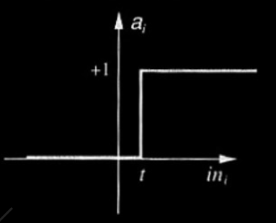

**Sign Function**

If x >= 0 then 1 else -1

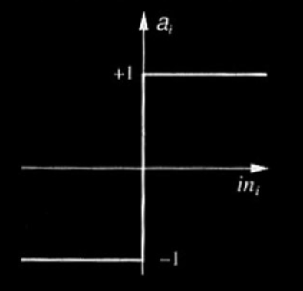

**Sigmoid Function**

**F(x) = 1/1+e-x**

